**Event Binding in Angular**

***Event binding allows you to listen for certain events such as keystrokes, mouse movements, clicks, and touches.***

***Angular event binding syntax consists of a target event name within parentheses on the left of an equal sign, and a quoted template statement on the right. The following event binding listens for the button's click events, calling the component's onAdd() method whenever a click occurs***:

<button (click)=”onAdd()”>Add<button>

***(click)=>It defines the target event name***

***onAdd()=>It defines the template event name***

***When a user interacts with an application in the form of a keyboard movement, a mouse click, or a mouseover, it generates an event. These events need to be handled to perform some kind of action. This is where event binding comes into picture.***

***Angular facilitates us to bind the events along with the methods. This process is known as event binding. Event binding is used with parenthesis ().***

***When the user interacts with a web application in the form of keyboard movement, keystrokes, a mouse click, double click, or a mouseover, on the form submits; it will generate an event. Those events need to be handled to perform some action. This is where event binding comes into the picture. It is a one-way data binding, in that it sends information from the view to a component class. It is opposite from***[***property binding***](https://coursetro.com/posts/code/58/Angular-4-Property-Binding-Tutorial)***, where data is transmitted from the component class to the view.***

***Example:1***

***app.componet.html***

<!DOCTYPE html>

<html lang="en">

  <head>

    <meta charset="UTF-8" />

    <meta name="viewport" content="width=device-width, initial-scale=1.0" />

    <title>app</title>

  </head>

  <body>

    <h1>Welcome to Angular</h1>

    <div class="container">

       <button type="submit" (click)="onClicked()" class="btn btn-primary">Click</button>

    </div>

  </body>

</html>

***app.component.ts***

import { Component, OnDestroy, OnInit } from '@angular/core';

@Component({

  selector: 'app-root',

  templateUrl: './app.component.html',

  styleUrls: ['./app.component.css'],

})

export class AppComponent  {

  title = 'Angular-App';

  onClicked(){

    alert(" on Clicked is called");

  }

  }

***Browser Output::***

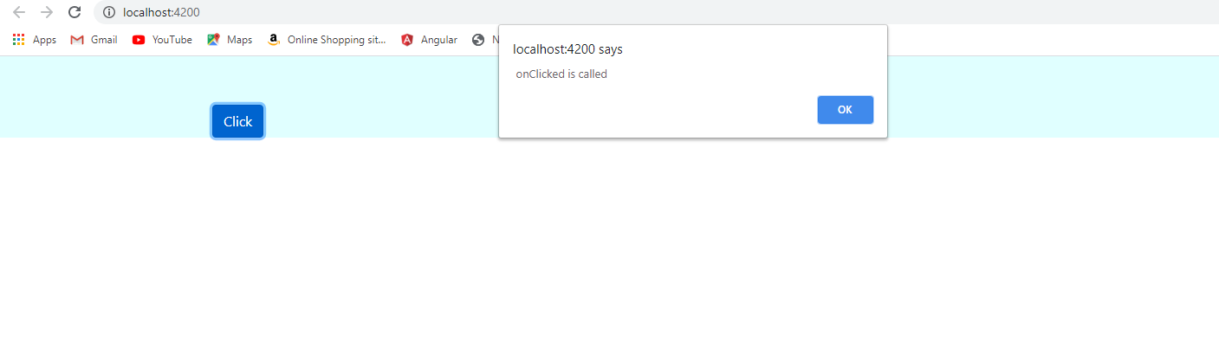

***When user is click the click button the event will be raised***

***Execution Flow***

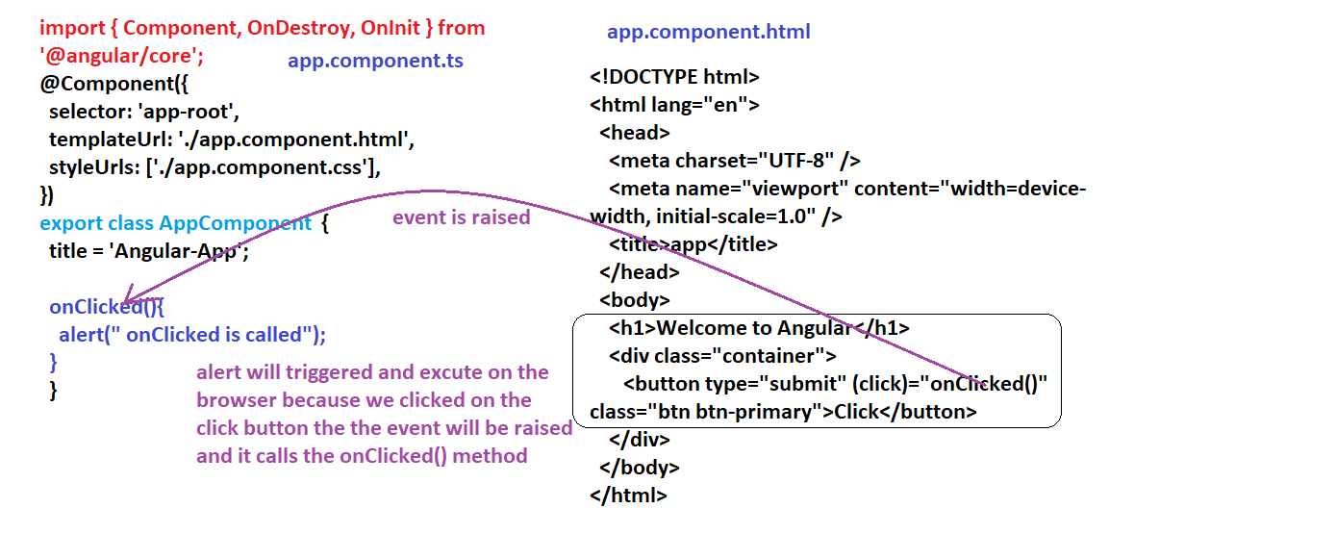

***First user clickes the clickButton the click event is raised the method we defined is onClicked() that method is triggered to app.component.ts file***

***Of onClicked(){ …..} what the statements are inside the onClicked{…} that statements will be executed line by line until the method signature ends***

***In this method we have the alert statement it alerts on the browser to display the statement what we had written on the alert method.***